PRIVATE 38489 WILLIAM BRUCE JOHNSTONE MM
LANCASHIRE FUSILIERS
 | 1ST BATTALLION 1915 – 1917
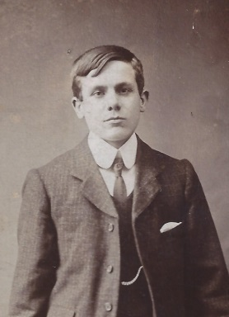 |  | 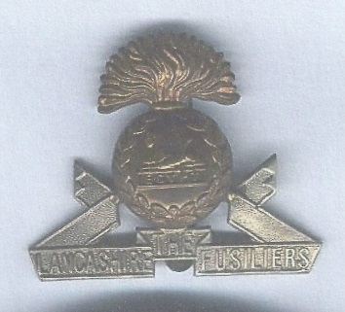

William Bruce Johnstone was born on the 8th June 1889 at Choppington, Northumberland. His mother was Mary Jane Johnstone who was a domestic servant. His grandfather, also William Bruce Johnstone, was an Under Manager at Choppington B Colliery and then the landlord of the Anvil Inn at Guide Post, Northumberland (1901). William Bruce Johnstone married Jane Jordan in the parish church at Choppington on 3 January 1912, when they were both 22 years of age. They and had two sons George Jordan Johnstone and Robert Hedley Wheatley Johnstone who died, before he reached the age of one, in 1915. William Bruce Johnstone was a butcher and enlisted in the Lancashire Fusiliers at Bedlington.

William Bruce Johnstone was awarded the Military Medal (MM) between the 5th and 13th of July 1917. The award of the MM was announced in the London Gazette on 17th September 1917. Details of how the MM was gained are shown below.
At Rivoli Farm, “B & C Companies were carrying up Lievens gas shells from the railroad to the gun pits, part of the way on trolleys where the Bosche had not blown the line up, and the rest carrying. This was successfully done in spite of difficulties caused by the Bosche, who, on one evening put down a barrage for over an hour on the trolley line where the men were. By great luck he did not explode any of the gas shells. For gallant conduct on this occasion Pte’s Hind and Johnson* (verified Johnstone) of C Company were awarded the Military Medal”

Events leading up to October 1917 for William Bruce Johnstone and the 1st Battalion Lancashire Fusiliers
- Took part in the Third Battle of Ypres on 16th August.
- In the line near Langemarch during for rest of August 1917.
- September 1917 training at Purbrook, Haringhe, 6 miles NW of Poperinghe.
- Period in September spent in the forward area under the direction of a tunnelling company.
- Final preparation for battle included washing all feet at Elvderdinghe baths, 7th October.
- Night of 7th October 1917 took over the line 800 yards NE Langemarch.
- Orders issued on the 8th October detailing the action on the 9th.
- First objective the ‘Green Dotted Line’ 500 yards from the front line.
- The second objective was the ‘Blue Dotted Line’ a further 500 yards.
- Much rain had fallen during the night of 8/9th October, there was no moon.
- The whole Battalion was in place by 0510 hours after losing some Companies.
- Zero hour was at 0520

William Bruce Johnstone, a member of ‘C’ Company, was killed during the action on the 9th October 1917. There is no exact information as to how he died on that day however; about 0600 hours just as ‘C’ Company began its advance, the enemy counter attacked which caused considerable casualties. Other information shows that during the same period to get to the ‘Blue Dotted Line’ some of our artillery fell very short and men were hit with shrapnel.

William Bruce Johnstone is buried at Langemark Cemetery, a small village 4 miles from Ypres in Belgium. One Saturday in 1988 two grandsons of William Bruce Johnstone, Derek and Raymond Johnstone visited his grave and placed flowers on it. It is believed, that they were the first family members to have to the grave. The experience is a one which will be remembered by both brothers as will the memory of the surroundings where so many brave soldiers lie at rest having given their lives for King and Country.

Grave at Langemark  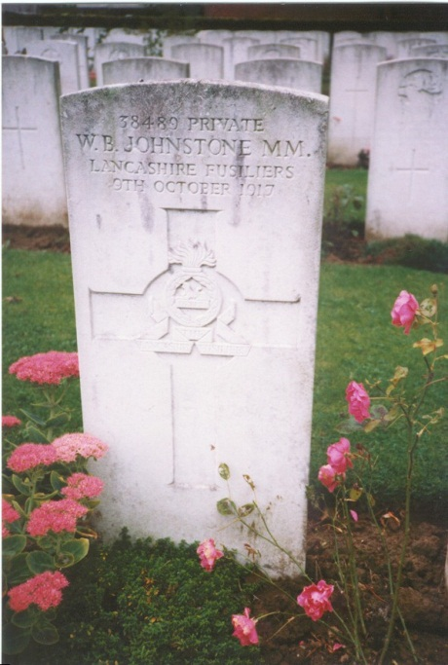 | 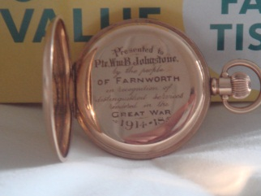  Watch presented to the family of William Bruce Johnstone by the people of Farnworth, Lancashire.

Grave reference XV.C.15

Following the death of his father William Bruce Johnstone in 1917 and his mother Jane Johnstone (nee Jordan) in 1915 George Jordan Johnstone (born 1912) his only surviving son, was brought up by his aunt Margaret Harvey. George Jordan Johnstone married Doris Hunter and lived until 1979 in Bedlington. George Jordan Johnstone had three sons and one of them was called William Bruce Johnstone.

